

SRI LANKA INSTITUTE OF INFORMATION TECHNOLOGY

[**Enterprise Standards and Best Practices for IT Infrastructure**](http://courseweb.sliit.lk/course/view.php?id=137)

**4th Year 2nd Semester 2016**

**Amazon EC2 Linux Instances**

Name: A.R.H Pramodi

SLIIT ID: IT13121020

Group Number: Group 02

Practical Session: <WD Friday>

Practical Number : <Lab 2 >

Date of Submission: 31-07-2016

Date of Evaluation : _____________________

Evaluators Signature : _____________________

1. Choose an Amazon Machine Image: Amazon Linux Server

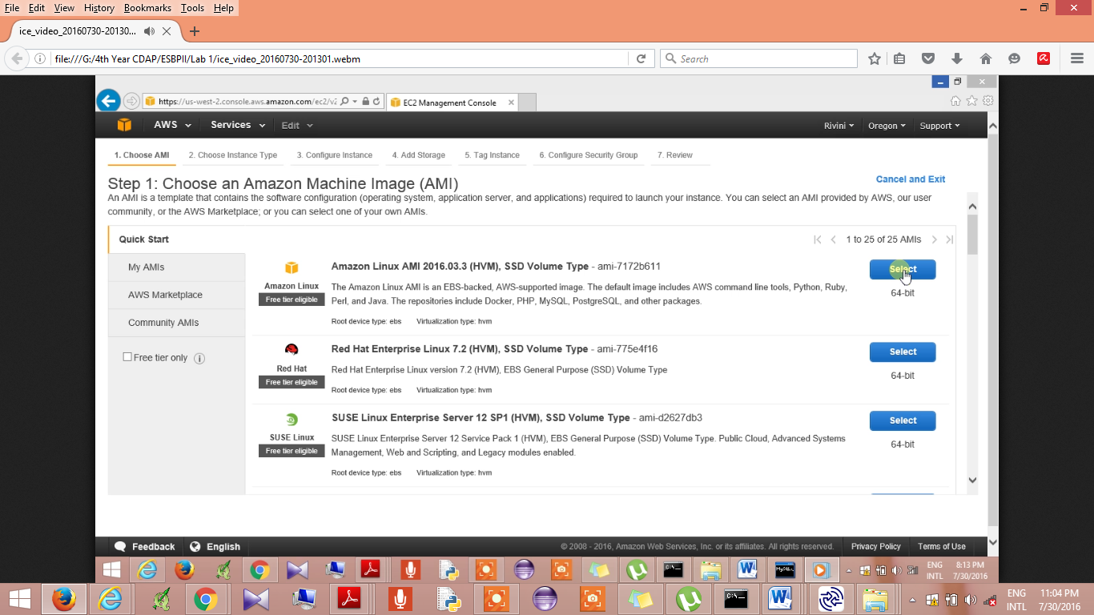

1. Choose an Instance type: General Purpose

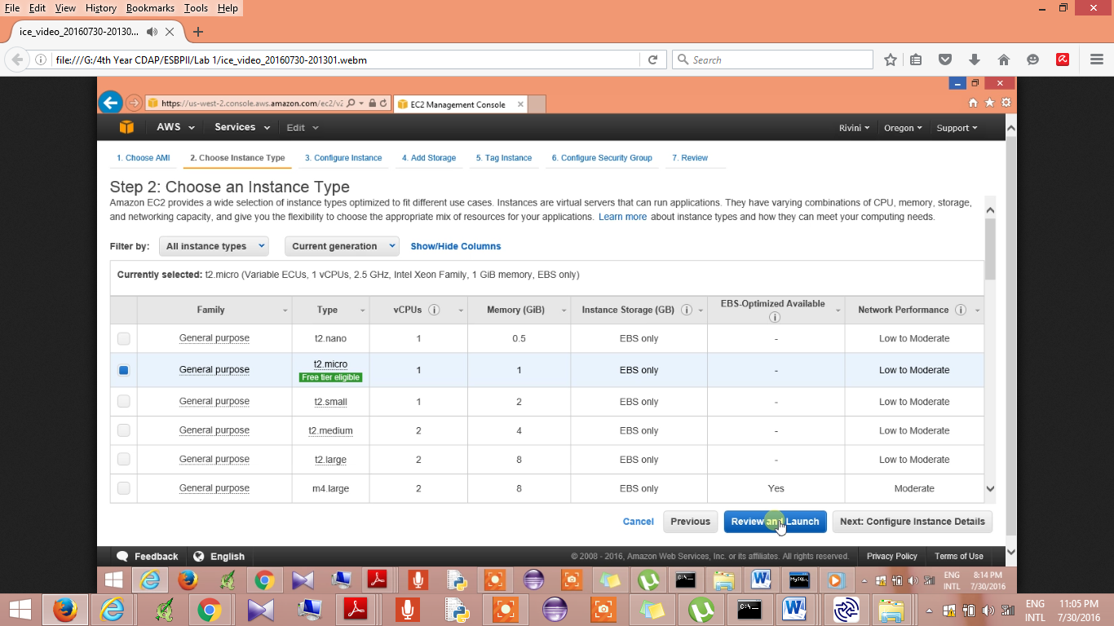

1. Configure Instances

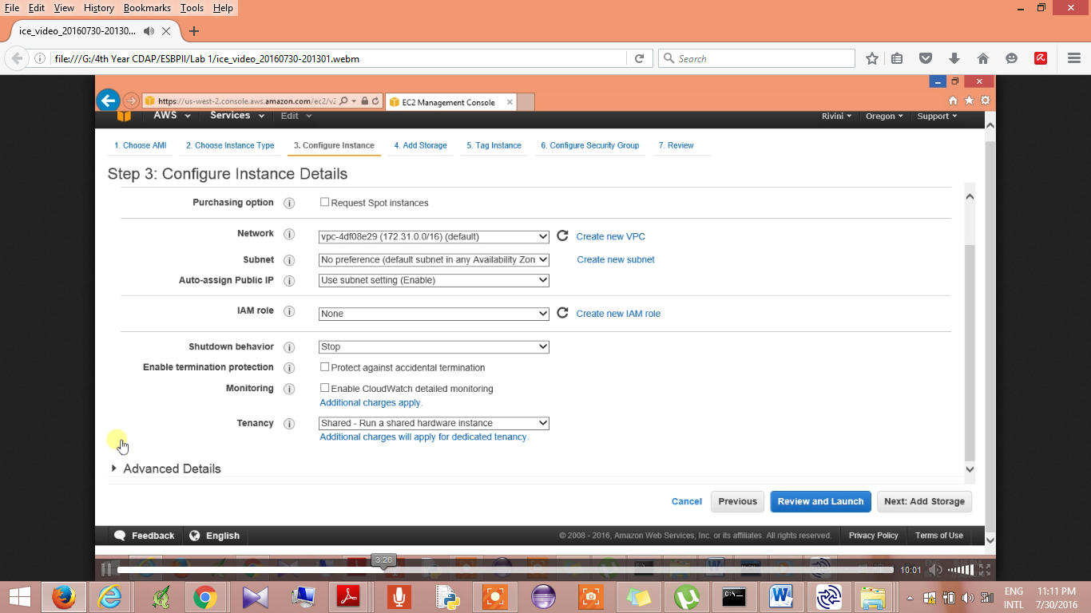

1. Add Storage

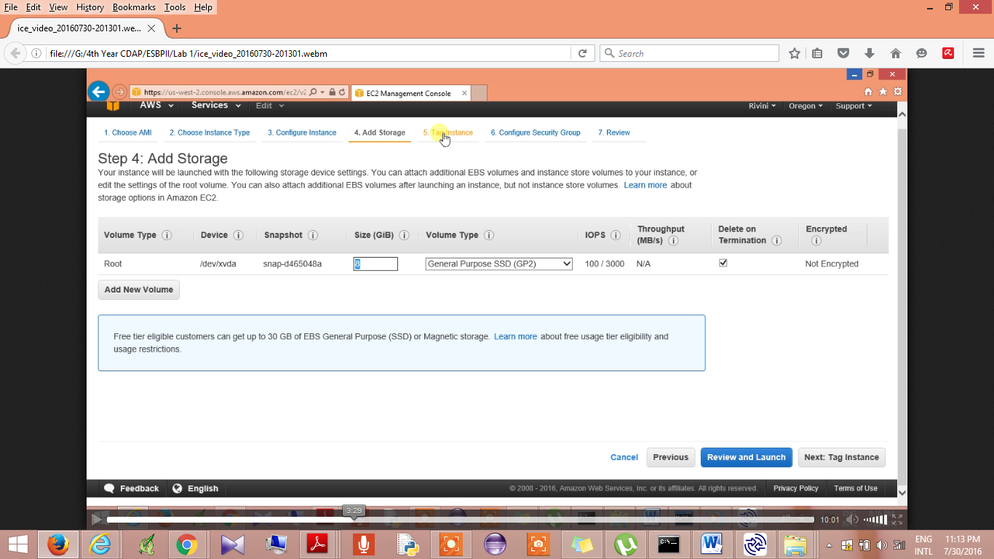

1. Configure Security Group

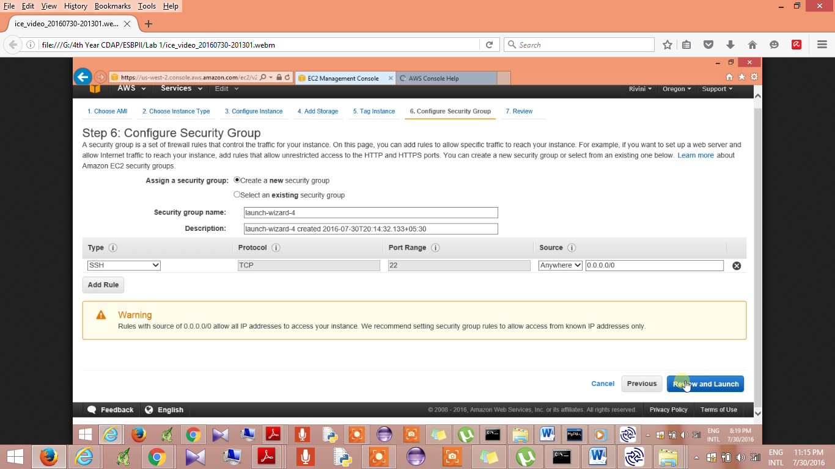

1. Review and Launch

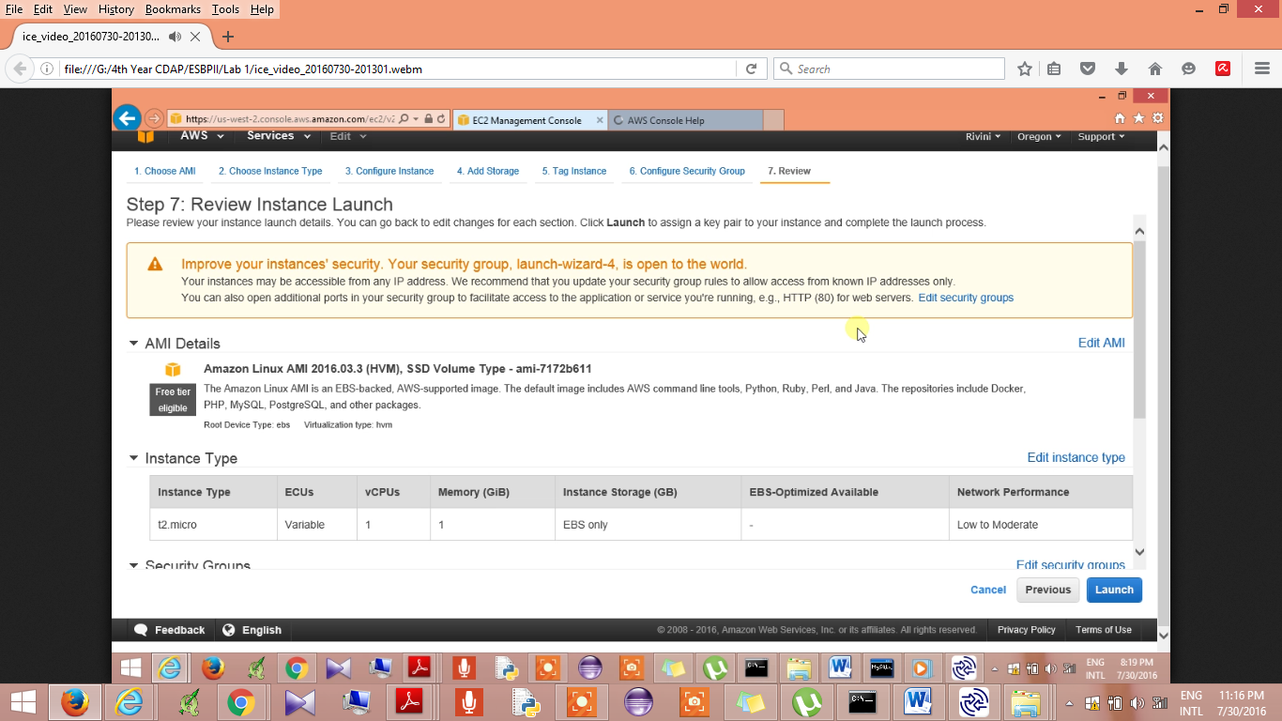

1. Launch Instances

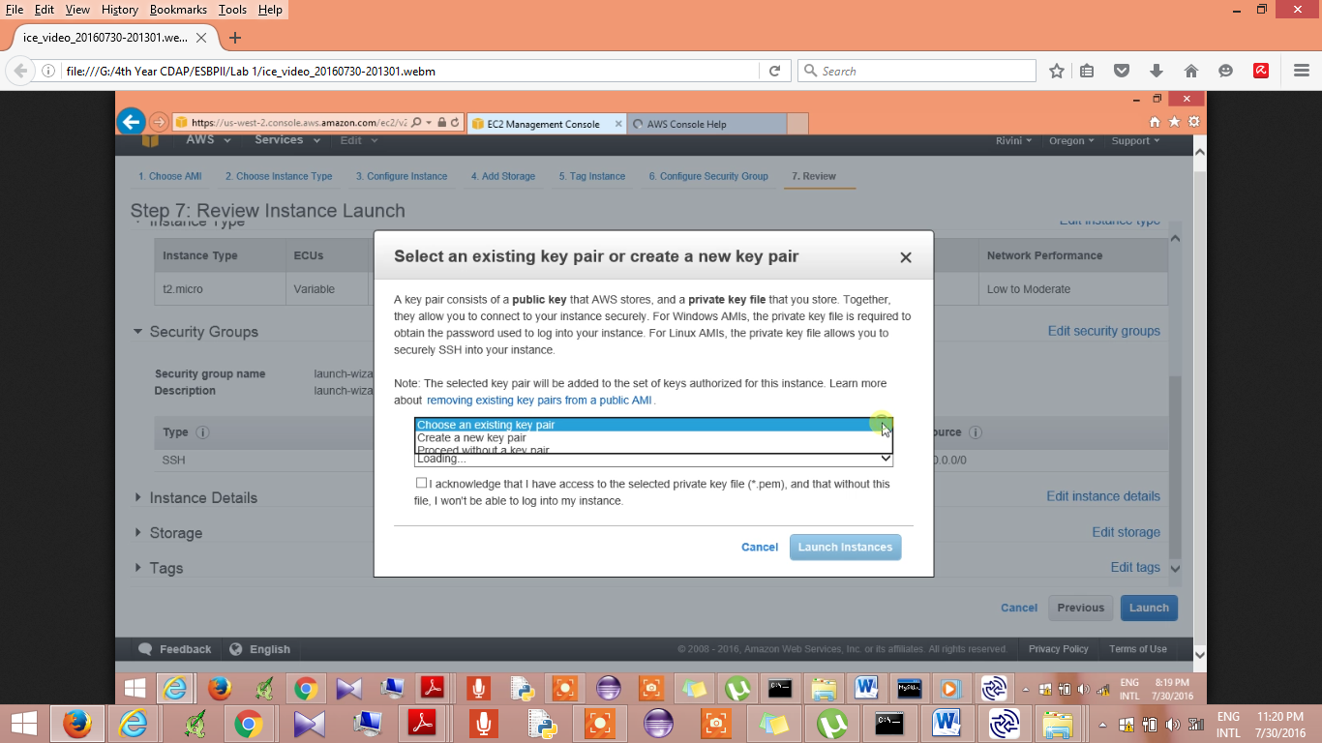

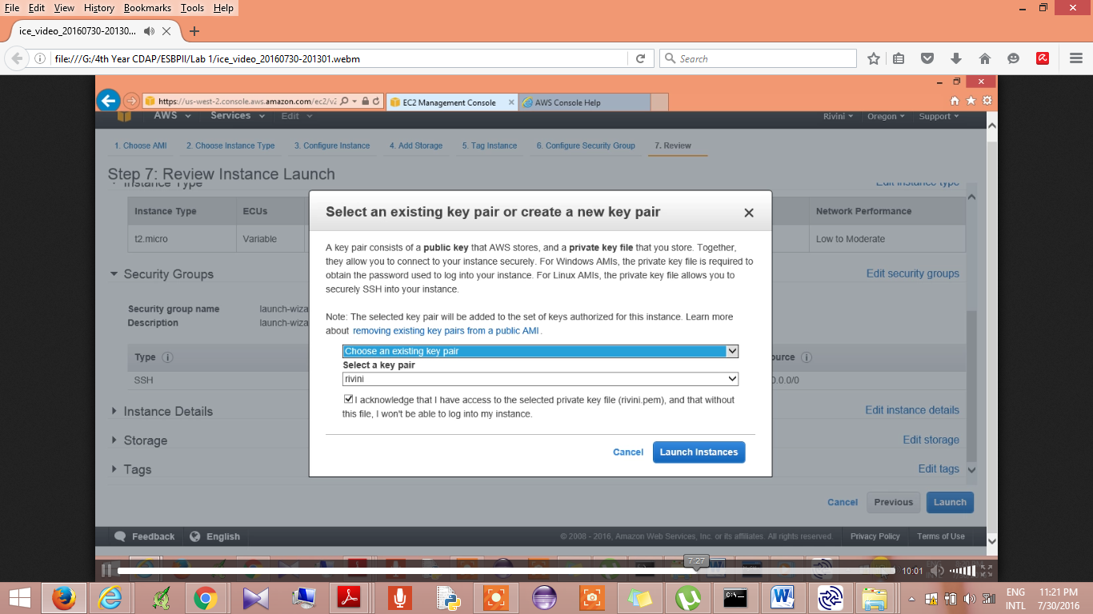

1. Connect Instance

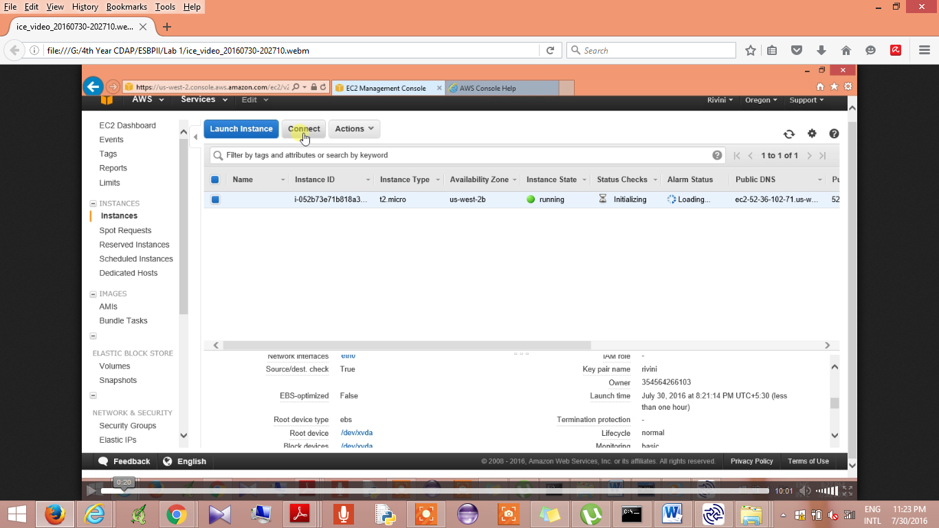

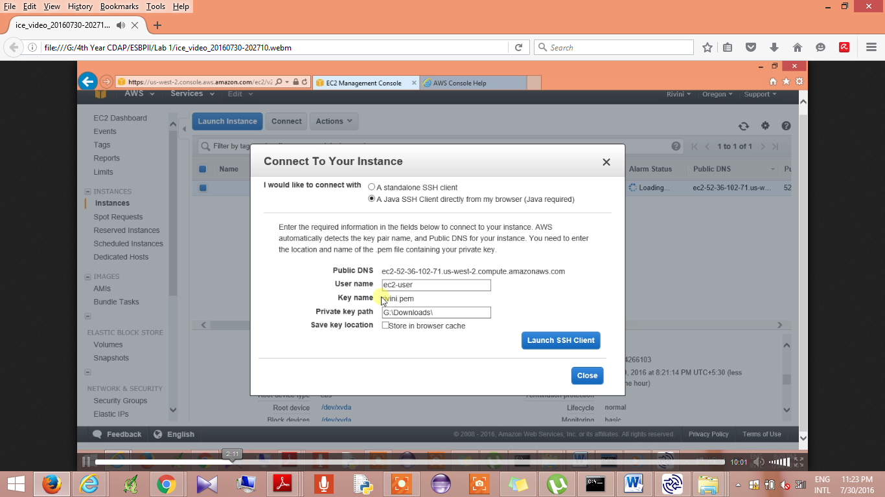

Check connection using putty

